Appendix 1 
Growth Hub Annual Report 2018-2019 (1st April 2018 – 31st March 2019)
LEP Accountable Body: | Lancashire County Council
Local Enterprise Partnership: | Lancashire Enterprise Partnership
Growth Hub name: | Boost Business Lancashire
Date of Annual Report: | April 2019
Name of person completing report: | Steve Hoyle
Job Title: | Growth Hub Performance Coordinator
Contact phone number: | 07885 780992
Contact email address: | steve.hoyle@lancashire.gov.uk
Deadline for return to BEIS: | Friday 31st May 2019

This template has been produced by the Department for Business, Energy and Industrial Strategy (BEIS) to help aid the production of 2018-2019 Growth Hub ‘Annual Reports’.
LEPs are asked to ensure that information is included that will be helpful to enable BEIS to assess how individual Growth Hubs are progressing and to aid the identification of best practice and local innovation to help inform the ongoing development of the Network.
LEPs are however; free to use an alternative format for their review (e.g. where part of LEP Annual Report) as long as the key content areas specified within the template are incorporated within final reports. This will ensure a level of consistency in order that BEIS and any externally contracted evaluation organisations are able to compare and contrast information presented by different Growth Hub models and typologies.
BEIS also need this information to ensure consistency and transparency and to help demonstrate the impact to HMT and others that the funding provided by BEIS in 2018-2019 has increased the level of take-up of business support and is helping to drive business growth in local places. This information is therefore critical in helping to inform the future development of Growth Hubs and in helping to shape future policy thinking.
BEIS therefore request that LEPs submit their Growth Hub Annual Report to BEIS in word format (not as a pdf) and that each section should provide the details requested in a short, informative and concise way without losing the key information. BEIS would also be grateful if LEPs avoided referring BEIS back to other reports for information, but provided the information needed to answer each question within the body of the template.
Annual Reports should be submitted to Growth.Hubs@beis.gov.uk no later than Friday 31st May 2019 and copied to your Area Lead.

Executive Summary
- Please set out the primary objectives and priorities of your Growth Hub for the 2018-2019 funding period and the high-level achievements from the last twelve months demonstrating how these objectives have been met (1st April 2018 – 31st March 2019).
Objectives
Boost is the business Growth Hub for Lancashire. Its role is to promote access to high quality business support to SMEs who have the desire and ambition for growth. The Hub engages with and undertakes initial diagnostics within the SMEs and works with them on an ongoing basis to ensure that their needs can be advocated to the various strands of Boost support and to appropriate help provided by other business support agencies and private sector services at local, regional and national level. The local service is backed up by the National Business Support Helpline and highly skilled account managers together with a web based information service.
https://www.boostbusinesslancashire.co.uk
The prime aim is to accelerate the growth of Small to Medium sized enterprises (SMEs) in Lancashire, to stimulate new investment and job creation by systematically identifying and removing the barriers to their growth, by encouraging innovation and in promoting enterprise. The project addresses ongoing weaknesses within the Lancashire economy and market failures to provide the range of business support needed by growth businesses in Lancashire.
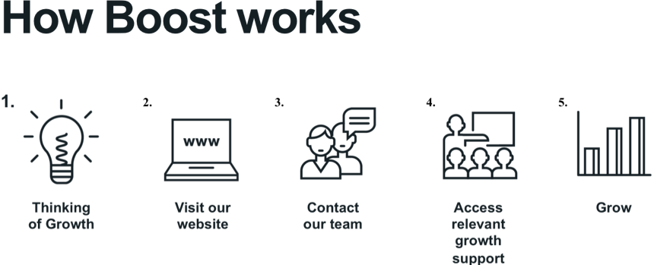
The core objectives of Boost are:
- To promote a programme of high quality business support to Lancashire SMEs
- To encourage entrepreneurship and the sustainable growth of Lancashire businesses
- To foster innovation, product development and business resilience;
- To encourage business support agencies to work together to provide a coordinated and easily understood business growth offer

Headline Achievements 2018-19
Total Number of Businesses engaged: 1031
Number of businesses receiving intensive support: 542
Potential entrepreneurs supported: 48
Number of new businesses launched: 209
Additional GVA secured: £14,279,043
Over the past 12 months, in addition to these core achievements, considerable progress has been made in developing new strands of support; for example the introduction of 'Boost Bespoke' in January 2019 to support those businesses focusing on new products, new markets and those with Scale-Up ambitions.
Further progress has been made in relation to the coordination of business support with the development of GDPR compliant data sharing agreements between business support partners across Lancashire.
The Key features and strengths of Boost:

- A strong focus on delivery
- An emphasis on growth potential
- Strong project management ethos
- Virtual hub model with low overheads and operating costs
- Well-coordinated with other public and private sector business support
- 100% performance related delivery contracts drives VFM

Growth Hub 2018-2019 Grant Spend Position
B. Please confirm details of the financial position in respect of your 2018-2019 grant.

Total BEIS grant for 2018-2019 awarded | £328,000
Estimate of any underspend of the 2018-2019 awarded at this time (please provide reason for underspend) | £0

Breakdown of grant spend throughout the financial year.
£ Funding spent
Q1 – 1 April to 30 June 2018 | £82,000
Q2 – 1 July to 30 September 2018 | £82,000
Q3 – 1 Oct to 31 December 2018 | £82,000
Q4 – 1 January to 31 March 2019 | £82,000
TOTAL GRANT SPENT OR COMMITTED* | £328,000
Please provide a breakdown of the expenditure by activity to help inform a BEIS internal audit of Growth Hub budget spend in 2018-2019 (this can be taken from the Excel spend spreadsheet which accompanies every claim submitted to BEIS).
Note that this only relates to core BEIS Growth Hub funding and not any other locally accessed funding streams e.g. ERDF:
Per activity as shown on your Schedule 1 form | Full year spend  £
Northern Automotive Alliance SLA, Salary Costs for Specialist Advisors | £50,000
North West Aerospace Alliance SLA, Salary Costs for Specialist Advisors | £50,000
Executive and Management Salary Costs | £45,319
Access to Finance SLA, Salary Costs for Specialist Advisors | £110,226
Creative Sector Engagement, Salary Costs for Specialist Advisors | £51,209
Client Engagement, Business to Business Events and associated costs | £21,246
Total | £328,000
Please confirm what sources of additional funding and/or resources have been leveraged in by the LEP and/or Growth Hub in 2018-2019 to add further value to your Growth Hub service? Where possible please provide top line detail on how this funding and/or resource is being used. What are the benefits of this to the Growth Hub and its customers?
Funding:
In addition to BEIS funding, the LEP has secured funding from Lancashire County Council and from ERDF. This amounted to £2,430,184 in 2018-19. This funding pays for the delivery of the Growth Hub services to business and for the Project Management Team within LCC.

The Boost ‘offer’ to businesses is made up of a number of core ‘products’ or services They are:
- Business Relationship Management (Client engagement and referrals)
- Growth Support Programme (Support for new businesses)
- Growth Mentoring (support for established businesses)
- Boost Bespoke (Scale Up support, new products/markets)
- Boost Marketing (programme wide business engagement)
A team of 5 staff within Lancashire County Council’s Economic Development Service manage the delivery contracts. By separating the management and delivery functions in this way there is a strong focus on performance and the effectiveness of the delivery mechanisms. The contractual arrangements mean that there are strong financial incentives for the procured organisations to deliver against agreed targets and there are clear mechanisms for managing performance.
Other resources:
N/A

Progress of Growth Hub in 2018-2019
C: Summary of Growth Hub progress in 2018-2019

- Strategic Partnerships

- Please confirm how the Growth Hub was delivered in 2018-19 (i.e. in-house, external, consortium of partners). Please confirm if this delivery model will continue or if there are plans to change this/re-procure in the next twelve months. Please confirm:

  - The primary organisation/s delivering the Growth Hub and whether they are a public or private sector organisation?
  - If delivered externally, the relationship under which the Growth Hub is delivered? (i.e. memorandum of understanding, service level agreement, informal arrangement etc.)
  - What do you perceive to be the benefits of this approach to the LEP and your Accountable Body?

Oversight and strategic direction for the Growth Hub is provided by the Lancashire Economic Partnership (LEP), with Lancashire County Council providing accountable body functions for Growth Hub funding. To ensure proper coordination, consistency and technical input, the day to day management of the Growth Hub is vested with the Business Growth and Innovation Team within the County Council, along with the management of the Lancashire Skills Hub.

The Growth Hub model in Lancashire consists of a small Project Management Team (5 posts) within the Lancashire County Council, with all direct delivery of support to businesses being contracted out to specialist business support organisations.

The delivery model was substantial refreshed and upgraded in January 2019 based on a careful evaluation of the model and business trends over the previous 3 years and the current challenges facing business. The evaluation recommended a closer focus on the growth potential of local businesses and building stronger relationships with business over time rather than short term interventions and signposting.

Five delivery contracts were procured in late 2018, with new delivery contracts coming into operation in January 2019. Each contract is 3 years in duration (2019-21) and funded through a combination of LCC and ERDF funding.

The successful contractors were:

Business Relationship Management – Growth Lancashire Limited (Company Limited by Guarantee)

Growth Mentoring – Community and Business Partners (Company Limited by Guarantee)

Growth Support Programme – Winning Pitch Limited (Private Limited Company)

Boost Bespoke - Winning Pitch Limited (Private Limited Company)

Boost Marketing – Freshfield Limited (Private Limited Company)

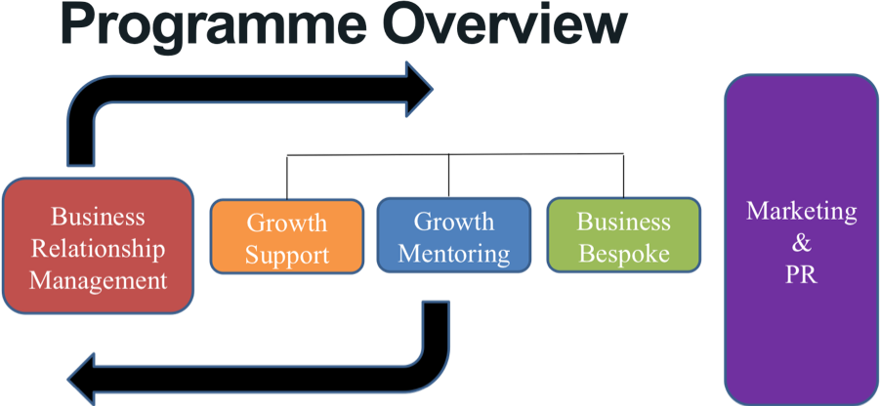

Concerning the benefits of this approach, by separating the management and delivery functions in this way there is a strong focus on performance and the effectiveness of the delivery mechanisms. The contractual arrangements mean that there are strong financial incentives for the procured organisations to deliver against agreed targets and there are robust mechanisms in lace to manage performance.

- How did the LEP explore and support cross-boundary working with other LEPs, Growth Hubs and strategic partners in 2018-2019 to ensure value for money (e.g. cluster working; joint projects, sharing resources etc)?

In terms of local geography there are no issues with overlapping LEP boundaries in the North West Region. Traditionally, Lancashire has had a natural economic and cultural affinity with the Manchester area and our closest working relationships reflect this. We have therefore supported specialist business support services that can operate more economically on this wider footprint by coordinating activity and funding with the Manchester Business Growth Hub.
Lancashire is an active participant in both the North West Growth Hub and Northern Powerhouse Growth Hub network meetings. Lancashire have taken the lead on trying to benchmark delivery and performance across Hubs in the North and attempted, with colleagues from Humber and Sheffield City Region (SCR) to float the idea of a Scale-Up North programme. Whist this has not progressed, shared activity, again with SCR has been proposed on the basis of the Science and Innovation Audit (SIA) which the two LEP's championed to explore the ability of Northern Advanced Manufacturing and Engineering businesses to respond to the challenges characterised as Industry 4.0. The SIA resulted in a series of recommendations to promote growth and foster innovation and productivity across the Northern Powerhouse area which we are now seeking to develop and advance as activity that would complement the emerging Northern Powerhouse and Industrial Strategies.
In practical terms, the Lancashire Growth Hub commissions and collaborates with colleagues in Greater Manchester on a number of programmes of provision, this includes a shared Access to Finance Team, and partner ERDF programmes on international trade and manufacturing support.
In relation to wider cross-boundary working Lancashire is collaborating in the ‘Made Smarter’ North West pilot project with the 4 other regional LEPs, and is a partner in the Northern Powerhouse Investment Fund. We have recently committed to supporting the NP11 initiative involving all LEP chairs focusing on innovation, trade and new investment.
- What approach has the LEP through its Growth Hub taken to continue to develop strong, inclusive strategic partnerships across the LEP and/or Mayoral Combined Authority area during 2018-2019?
  - What have been the successes and have any local challenges been overcome?
  - Have any new relationships, networks or clusters been created?
  - What cross-border working has been undertaken?

Collaboration, networking and good communication are driving principles for Boost and we encourage the sharing of intelligence and good practice across the business support environment in Lancashire. We work closely in particular with the Lancashire Universities, local authorities but also with business intermediaries such as solicitors and accountants to ensure that businesses are directed to the most relevant business support.

We are also developing stronger links with local business forums – Blackburn Hive, Burnley Bondholders, Skelmersdale Ambassadors and Pendle Business Leaders both to ensure that business views are reflected to service providers and to promote the awareness of the support available through the Growth Hub.

There is an ongoing concern that despite active marketing and varied business engagements activities, companies who make use of the available support are in the minority (approximately 1 in 10 businesses). Yet the vast majority of businesses who do receive support report a positive outcome.

- How has the LEP ensured that the Growth Hub has been embedded in any upcoming Local Industrial Strategies? What progress has been made to date?
The Lancashire LEP places a high priority on securing a professional, proactive and valued business support infrastructure across the county. It recognises that many businesses can be assisted on their growth journeys through access to relevant and high quality support. The Lancashire Economic Partnership therefore takes a close interest in the role that Boost Business Lancashire, our Growth Hub, plays in facilitating the growth process of Lancashire businesses.
To date, the Growth Hub has featured prominently in the LEP’s strategic plans for the Lancashire economy. This is demonstrated by its inclusion in the Lancashire Strategic Economic Plan and the European Structural and Investment Funds Strategy for Lancashire. Furthermore, in the allocation of EU funds within Lancashire, the LEP has made it a condition of funding that all business support projects work closely with the Growth Hub. This process is underwritten by a formal Memorandum of Understanding and Data Sharing Agreement that set out the parameters for all such projects to coordinate activities with the Growth Hub.
The Growth Hub to feature strongly in future LEP strategic plans including the emerging local Industrial Strategy for Lancashire and the emerging Lancashire Plan, particularly in respect of business support interventions that will target and drive productivity.
The LEP has recently appointed the economic consultancy the Steer Group to produce the Lancashire Industrial Strategy and the draft report is expected in September 2019. Their brief includes a mandate to reflect the Foundations and Grand Challenges contained in the national Industrial Strategy.

- National and Local Integration

What approach did the LEP take, via the Growth Hub, to develop strong, inclusive partnerships with all of the local and national players (public and private) involved in the ongoing development and delivery of the Growth Hub? Please provide a summary of working relationship in 2018-2019:

Sector Deals:

Priorities for support during 2018-19 have been the automotive, aerospace and digital/creative sectors. We have used our BEIS funding to engage and work with the North West Aerospace Alliance and the Northern Automotive Alliance to provide specialist support for growing businesses in these key sectors. The funding has also been used for
Creative Sector engagement, again using a specialist advisor.

Innovate UK (IUK) / through Science and Innovation Audits:
We are committed to working with and informing the Northern Innovation Strategy;
Knowledge Transfer Network (KTN):
We are currently exploring the training of our business advisors to use the 4Manufacturing tool to support local manufacturers to deploy digital technologies to improve productivity and innovation.
Department for International Trade (DIT) / Enterprise Europe Network (EEN):
We have supported the co-location of an advisor to handle FDI enquiries and liaison with foreign owned companies in Lancashire and working with DIT to support Lancashire businesses with international trade intentions. We are keen for local businesses to develop their capacity for international trading and we have recently met with DIT to explore the working relationships with the Growth Hub, looking at how we develop mutual referrals.
British Business Bank (BBB):
We support cooperation on the Northern Powerhouse Investment Fund and start up loans, signposting businesses to the Business Finance Guide, and signposting business with scale-up potential to the BBB digital information hub. We continue to work with the British Business Bank’s Regional Relationship Manager and new Regional networks being developed by the Bank;
Intellectual Property Office (IPO):
We make use of the database of patent registrations and promote their master classes to relevant businesses;
Be the Business (Productivity Leadership Group):
We support the ‘Productivity through People’ initiative at Lancaster University;
Banks:
We work closely with all of the major banks in relation to loan funding for businesses and encourage joint working on business support workshops and forums in Lancashire.
ICAEW / Accountants:
We work closely with the main accountancy businesses in Lancashire, with mutual referrals of clients and participation in joint business support events covering a wide range of topics.
Angel Networks:
We provide direct financial support for a regional investment fund (Access to Finance) and manage a local fund (Rosebud) to enable local businesses to access a range of appropriate funding sources.
Universities/Business Schools:
We work closely with all of the universities in Lancashire most particularly in relation to product development and innovation, but also in relation to leadership and management capabilities and degree level apprenticeships.
Enterprise Zones:
We are actively involved in the development of all of the Lancashire based Enterprise Zones, including the Lancashire Enterprise Zone, Samlesbury Aerospace Enterprise Zone, Blackpool Airport Enterprise Zone and the Hillhouse International Enterprise Zone;
Catapults/Incubators and Accelerators:
We have supported the establishment of an Advanced Manufacturing Research Centre satellite in Lancashire and Manufacturing Technology Centre innovation solutions for the fracking sector.
Better Business for All (BBfA)/Regulators:
Boost is keen to do more with Better Business for All to provide an alternate and business positive access point to local and national regulatory services. The BBfA website is listed on the ‘Support Available’ page of the Boost website and we have asked BBfA to provide further marketing collateral to highlight their available services locally.
Libraries/Business & IP Centres:
We have briefed the libraries service on the nature of the Growth Hub support and provided marketing documentation and contact details so that businesses using the libraries to search for business support can be directed to Boost.
Others (public and private):
BEIS are particularly keen to know about any good examples of partnership working with the private sector. If there are any key private sector partners that you wish to mention please do so here, including a short summary of the type of activity taking place and how it could benefit the wider Network.
Boost & Co
We feel that an initiative worthwhile highlighting is our ‘Boost & Co’ partnership.
Boost & Co: Boost not only provides a number of funded programmes that provide direct delivery to businesses. Boost has a membership group of other private and public sector business support providers called Boost & Co. Members include accountants, law firms, venture capital firms, banks, colleges, business membership organisations, networking groups and many more. Members of Boost & Co have specific services and offers that can help businesses grow.
The core Boost programmes therefore work closely with Boost & Co to ensure that businesses across Lancashire have access to the most relevant support for their specific needs. In practice, this is manifested in a number of joint events for businesses and mutual referrals to business support services.
Whilst Boost & Co does not currently charge either a membership fee or recoup income from business referrals, both of these areas of income generation could be explored in future.
The quality and reputation of Boost & Co participants is vetted at the point when businesses seek "membership", we have also removed companies from this groups where legitimate complaints have been made.

- Governance

- Please confirm the governance arrangements that were in place in 2018-2019 and the role of the LEP and Accountable Body in providing oversight and ensuring compliance of the Growth Hub. If your governance arrangements changed during the funding period/or are set to change in the next three months, please provide details of:
  - Why governance arrangements were/need to be change(d)?
  - What new measures were/will be put in place?

Please ensure you include the role of the LEP and Accountable Body in providing oversight and compliance of the Growth Hub (including line of sight back to LEP Board and national LEP Local Growth Assurance Framework).

Boost, the Business Growth Hub for Lancashire, operates under the direct leadership and governance of the Lancashire Enterprise Partnership (LEP). The overall governance structure for the Growth Hub is shown below. These arrangements have not changed over the 2018-19 period.
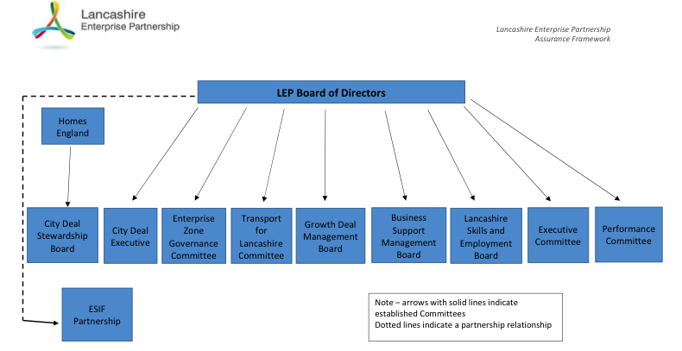
In relation to providing the overall governance and leadership of the Growth Hub, the LEP has established a formal sub-group, its Business Support Management Board (BSMB), to oversee the strategic direction, relevance and performance of the Growth Hub. The Group comprises representatives from the business sector in Lancashire and has a strong private sector focus. The BSMB ensures that Boost activity supports the Lancashire Strategic Economic Plan and the government's priorities as set down in the Industrial Strategy and national LEP Local Growth Assurance Framework.
Its terms of reference are to:
- Develop and promote business support strategy, initiatives and programmes aligned with agreed priorities, as part of the Strategic Economic Plan;
- Co-ordinate and commission a publicly funded business support offer that is clear, fit for purpose and which complements both commercial and national offers;
- Commission and maintain an evidence-base to help understand key business support demands in the LEP area;
- Identify and work with other LEP areas on business support issues of strategic and cross-boundary significance; and
- Advise on the deployment of business support funding directly accessed or influenced by the LEP and make best use of public investment in this policy area.

As Accountable Body, Lancashire County Council (LCC) takes responsibility for the day to day management of the Growth Hub, and has established a small team under the supervision of the Head of Business Growth and Innovation, to manage and monitor the performance of Boost. The team is supported in relation to compliance and performance matters by an independent advisor.

In line with the national review of LEP functions and governance, Lancashire is in the process of separating the physical location of the LEP core team from the County Council. An interim Chief Operating Officer for the LEP has been appointed and a new Chair for the LEP is being recruited. A new staffing structure for the LEP will be implemented once the Chair is in place. In terms of function the LEP will retain overall strategic responsibility for economic development and business support in Lancashire and the County Council will maintain the day-to-day management of the Growth Hub and Skills Hub.

- Triage. Diagnostics and Signposting

Local Infrastructure

- What Growth Hub delivery model/typology was employed during the 2018-2019 funding period?
  - Was this consistent or did it change during the twelve-month period? Why was this delivery model/typology chosen?
  - What value did it add over other models?
  - What was the benefit to the businesses using the Growth Hub?
In terms of the overall approach, based on contracted out delivery, this has remained the same. However from January 2019 the Growth Hub Delivery model has been updated and developed significantly. There are several reasons for this:
The recent independent external evaluation of Boost has enabled us to review the delivery model for the Growth Hub and to refine the support we offer based on feedback from local businesses an our experience in managing the project over recent years. The first change involves the improvement of the business engagement process and the introduction of a more in depth Business Relationship Management function to replace the previous ‘light-touch’ diagnostic process. This change is also reinforced by the BEIS core Principles of Funding which encourage Growth Hubs to broker/introduce high quality face-to-face Account Managers that have the skills and experience to manage the relationship with the business over the life of the intervention.
Secondly, we have paid close attention to the national policy direction in relation to high/growth/scale up businesses We have therefore introduced a ‘Business Resilience’ strand of activity (branded Boost Bespoke) designed to examine the scale-up potential of key Lancashire businesses. This is again supported by the BEIS Principles of Funding for Growth Hubs.
We are also acutely aware of the uncertainties facing many business in relation to the future of international trade and have made provision, working in partnership with DIT and the local Chambers of Commerce to identify these businesses and to direct them to the most appropriate source of support for their specific industry sectors and target markets.

All Growth Hub Delivery will continue to be contracted out, with Lancashire County Council providing the management, coordination, performance management and funding compliance support for the initiative.

- Were any additional physical Growth Hub locations opened in 2018-2019? Please provide details (including why these locations were chosen).

Support to businesses is generally delivered either on their own premises or in a range of tried and tested locations across the county. However in January 2019 one of our providers, Winning Pitch Limited opened a new satellite office in Preston. Their former based was in Salford, outside the Lancashire Growth Hub area and the new office enables them to have a higher profile locally, makes them more accessible to local businesses and save travel time and transport costs for the advisors on the ground.

- Did the Growth Hub employ its own advisers/staff, or were contractors/delivery partners used?
  - How many were employed and what were their job titles/roles?

As stated above, all business support delivery is contacted out to commercial providers. Their approach is to have a small number of core staff and flexible arrangements with a pool of business advisors who they call off as demand dictates. These are a mixture of generalist and specialist advisors, but in terms of overall resource at any one time there are approximately 20 advisors available across the LEP area. The overall resource is complemented by the pool of business mentors (250+) managed by one of our contractors Community and Business Partners who provide 1:1 mentoring support to around 200 businesses per annum.

- Were Growth Hub staff generalists or did they have a specialism? Did advisers hold any accreditations (e.g. SFEDI)? What were the benefits derived?

We have encouraged providers to adopt SFEDI as the benchmark for their business advisors. This is a nationally recognised standard. More important however is the industry knowledge and experience that the advisors bring to the table enables the advisors to establish credibility with clients and to bring real value to the support they offer.

Winning Pitch has 5 advisors employed; all accredited to SFEDI level 5 and working towards level 7. Community and Business Partners have pool of 250 business mentors who they draw upon to support businesses through ongoing mentoring. Approximately 30 of these are accredited to SFEDI level 5 or equivalent (CMI). Growth Lancashire has access to a pool of 8 advisors accredited to SFEDI level 5.
- Did the Growth Hub use the Business Support Helpline? Please provide details. If the Business Support Helpline is not used please provide details of the local arrangements.

This has been complicated over the part 12 months due to GDPR issues related to the sharing of information between the Helpline and local Growth Hubs. Going forward we are working with the Business Support Helpline to signpost eligible (in terms of growth ambition) businesses to the Growth Hub, and we have placed contractual requirements on the provider of the Business Relationship Management service in Lancashire to work with the Helpline.
- How did the LEP ensure that the Growth Hub continued to proactively promote both public and private sector support services and programmes that provide businesses with access, and information to:
  - Enable them to trade internationally/any other internationalisation activity beyond trade support
From January 2019 we have introduced a new component to Boost Growth Hub services – Boost Bespoke, which provides support (working closely with DIT) for businesses wanting to introduce new products and services (either new to the company or new to the market) and to explore international trade opportunities.
We have supported the co-location of an advisor to handle FDI enquiries and liaison with foreign owned companies in Lancashire and we work locally with DIT to support Lancashire businesses with international trade intentions. We are keen for local businesses to develop their capacity for international trading and we have recently met with DIT to explore the working relationships with the Growth Hub, looking at how we develop mutual referrals.
  - Improve the take up of modern technologies that improve productivity (e.g. cloud computing, data analytics, CRM, automation/machine learning etc.)

We are fully supportive of the Industry 4.0 movement and as stated above we are looking to train advisors in the use of the 4Manufactuing Tool. Productivity is a key issue for us in Lancashire and measures to improve industrial output will be included in the forthcoming Local Industrial Strategy.
  - Stimulate investment in science, research & development
This is a high priority area for the Lancashire SEP. In practice we work closely with the Lancashire Universities for example on the Innovation Clinic at UCLan, and technology services at Lancaster Infolab to ensure that Lancashire businesses have access to the specialist support they need. We are in the process of developing a shared innovation resource to be based with the LCC Growth Hub Team involving the three Lancashire universities.
  - Adopt leadership & management best practice

We work closely with Lancashire’s universities in relation to the development of leadership and management capabilities and degree level apprenticeships for Lancashire busnesses.
  - Improve workforce skills and access the right talent/apprentices needed to grow
The Lancashire Enterprise Partnership has established a Skills and Employment Board to agree the workforce priorities for the LEP area. This in turn has set up a Skills and Employment Hub - a strategic team tasked with enabling a balanced, skilled and inclusive labour market which underpins and contributes to economic well-being and growth across the LEP area. That team is co-located with the LCC Growth Hub Programme Management Team and this promotes regular dialogue on business needs and challenges related to access to workforce skills.
  - Increase business awareness and participation in public procurement and major infrastructure projects
There are a range of support services to support SMEs in their ability to identify and bid for public sector contracts for services and infrastructure projects. Lancashire County Council has its own Procurement Team to support this activity and has established a Supplier Portal for potential bidders, and a live portal of current tender opportunities. Boost also works with private sector providers such as the Shout Network and ‘Lancashare’ and representative bodies such as FSB and IOD.
- What action was taken to ensure that the Growth Hub continued to simplify the local business support landscape (e.g. minimising duplication)?
Lancashire County Council and Lancashire Enterprise Partnership have played an active role in the promotion of business support simplification in the North West. This has been continued in recent years through the lead role of Lancashire County Council in coordinating local authority business support across the County and in managing the Business Growth Hub.
In managing the European Union (EU) funding for Lancashire, the LEP has a responsibility to allocate resources in such a way that they do not duplicate business support provision or cause the proliferation of support services. To this extent all ESIF funded projects are required to work together to ensure that businesses can clearly understand the map of provision. This is reflected in the signing of a Memorandum of Understanding that commits organisation to sharing information and working in cooperation to benefit businesses.
The Boost Business Relationship Management service refers businesses to the most appropriate source of support, both from the public and private sectors and maintains a live directory of all available support in Lancashire.
The outcome is that businesses know where to go for help and that they are directed to the organisations who can be of best support to them. In practice we have created a single access point for growth-minded businesses.
- Has the LEP and/or Growth Hub developed or purchased any new innovative online tools or localised on-line content in 2018-19, that might be of interest/benefit to other Growth Hubs e.g. diagnostic tools; benchmarking tools, rate and review systems etc? If yes, please provide details.

We have made significant enhancements to our CRM system (Evolutive):

- We have developed further the reporting mechanism to incorporate interactive charts which display live output information in a visual form. We have designed these around common outputs and regular reporting requests to allow users greater ability to interrogate the system. Below is a screen shot of our output charts dashboard for a particular project;

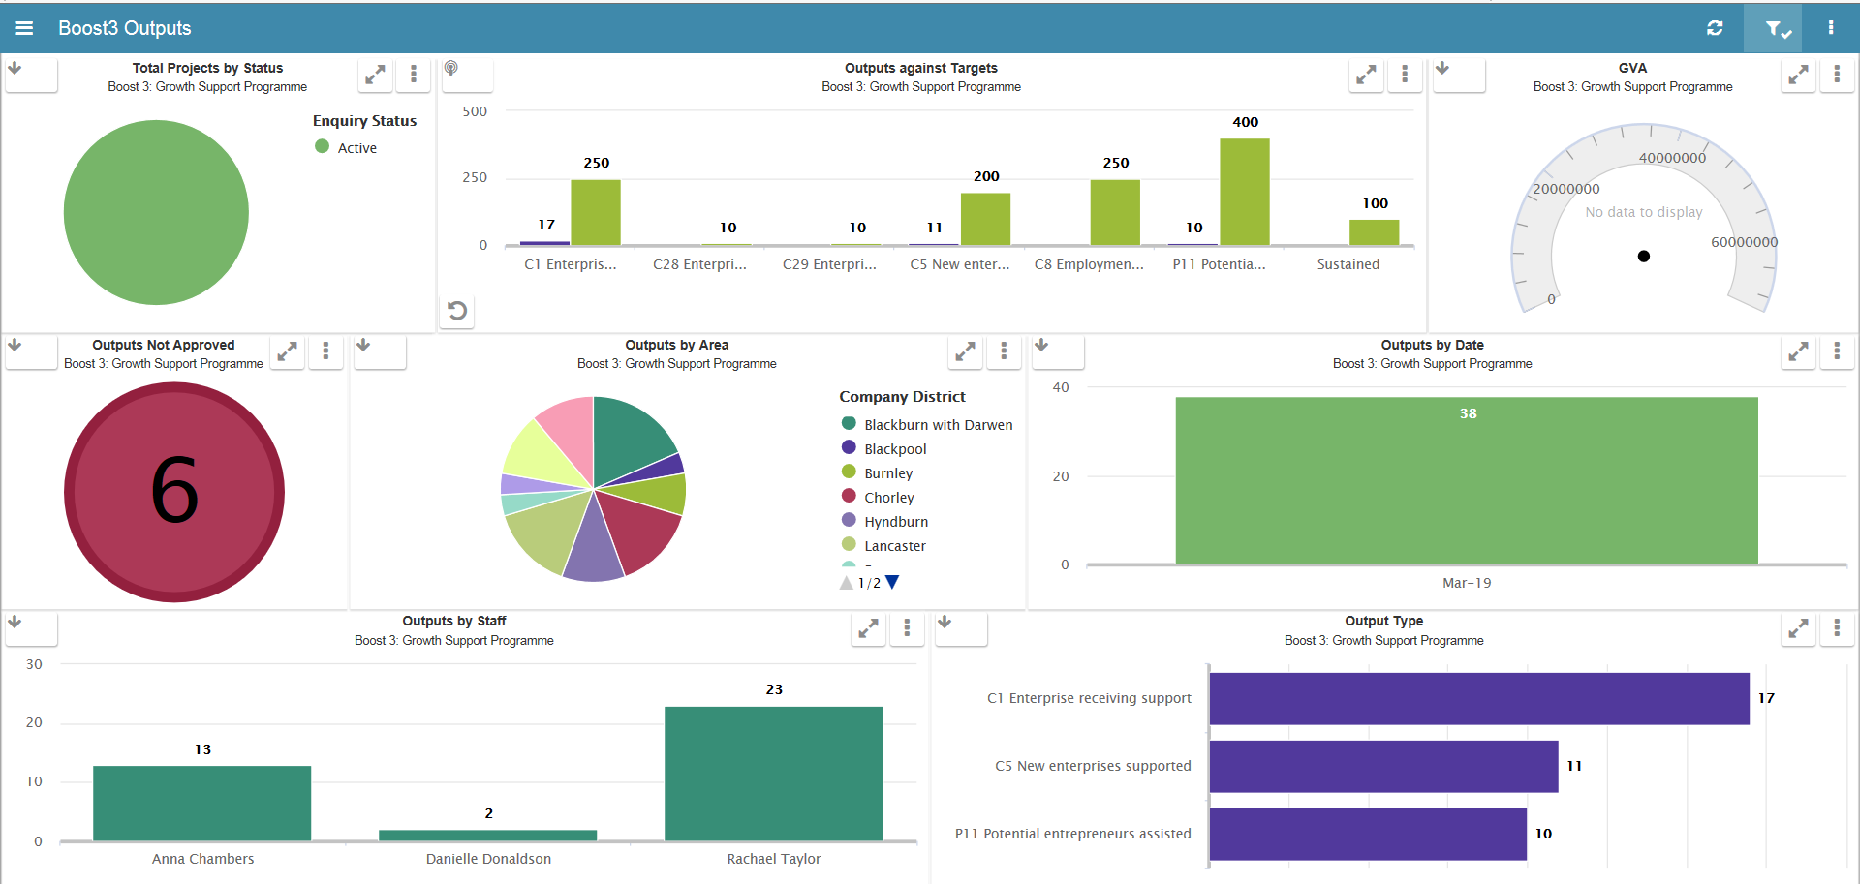

- We are developing a simple input screen that allows external partners running local business support projects, such as ESIF, to enter the details about this support into our CRM. Access will be subject to the partner signing the Memorandum of Understanding/Data sharing Agreement.
- We are also designing an easier way to monitor, report and input referral engagement against the referral provider. So for example, a simple screen which can query the referrals made to a particular project e.g. Lancaster University – Unite+, then have the ability to export and input engagement in the one screen. This will be easier than the current method we have where referrals are only stored against each individual client.
- Enhanced the way we track turnover and employee growth against clients.
- Updated the State Aid mechanism in the CRM that now takes into account ongoing support by introducing rolling totals.
- Created a formula which allow us to highlight new clients in the CRM, which haven't received the full ERDF 12 hours support in the past iterations of the Boost project.
- Improvements to the Satisfaction Survey process.
- Various minor changes obtained from the recent CRM user survey.

Overview of Key Performance Outcomes
D. Key Performance Outcomes. Provide information on the key outcomes of your Growth Hub linked to the requirements of the 2018-2019 ‘Metrics and Evaluation Framework’.

Indicator | Annual Total | Cumulative Total (since launch of Growth Hub) June 2013 - March 2019
Indicator | (1 April – 31 March 2019)
Number of businesses that have received ‘light touch’ triage, information and/or signposting support (excluding website traffic) | 1,031 | 5,831
Number of individuals[1] that have received ‘light touch’ triage, information and/or signposting support (excluding website traffic) | 389 | 1,872
Total number of unique visitors to Growth Hub website | 28,407 | 126,876
Number of businesses receiving ‘medium intensity’ information, diagnostic and brokerage support | 578 | 1,712
Combined turnover (amount £) of businesses receiving ‘Medium intensity’ information, diagnostic and brokerage support. | £438,196,117 | £1,755,521,548
Combined employee numbers (FTE) of businesses receiving ‘Medium intensity’ information, diagnostic and brokerage support. | 4843.75 | 17395.71
Number of businesses receiving ‘high intensity’ support e.g. account management / intensive support directly provided by the Hub or partner organisation | 542 | 2,455
Combined turnover (amount £) of businesses receiving ‘High intensity’ support i.e. sustained support and using significant Growth Hub resource. | £251,426,133.00 | £656,016,346.00
Combined employee numbers (FTE) of businesses receiving ‘High intensity’ support i.e. sustained support and using significant Growth Hub resource. | 2,725.92 | 19,912.28
Number of businesses receiving ‘Medium’ and ‘High intensity’ support that, have the opportunity, ambition and greatest potential to grow (including Scale-Ups) | 1,004 | 3,415
Total number of individuals who been helped to start a business | 209 | 699
Number of businesses referred to a mentoring programme (combined figure for ‘Medium’ and ‘High’ intensity interventions only) | 110 | 1,053
Number of businesses referred to a skills or training programme (combined figure for ‘Medium’ and ‘High’ intensity interventions only) | 199 | 833
Number of businesses referred to a finance and/or funding programme (combined figure for ‘Medium’ and ‘High’ intensity interventions only) | 319 | 1,432
Number of businesses referred to an innovation and/or R&D programme (combined figure for ‘Medium’ and ‘High’ intensity interventions only). | 56 | 747
£Private sector match secured (where linked to Growth Hub) | £296,722.89 | £1,276,063.57

Notes:
Measures such as “combined turnover” or “combined employee numbers” should only include the local business office receiving support (in the case of multi-site businesses). They will be calculated by aggregating the values recorded at firm-level. They should be the most recent values held by the LEP/GH at the point of reporting.
Measures such as “total number of businesses referred” do not need to reflect whether (or not) the referral was taken up.

- Customer Satisfaction

In line with the requirements of the 2018-2019 ‘Metrics and Evaluation Framework’ for ‘medium’ and ‘high’ intensity interventions only, please provide the tabulated responses to the satisfaction question set out below:

“How satisfied or dissatisfied are you with the quality of this service?” rated on a five-point scale.

1/5 | 2/5 | 3/5 | 4/5 | 5/5 | Total
9 | 18 | 34 | 105 | 487 | 653

For ‘light-touch’ interventions, a survey approach is sufficient. Questions that could be included based on standard questions asked of customers by all Growth Hubs.

“How likely would you be to recommend this service to a friend/colleague”, rated on a standard five point scale?

1/5 | 2/5 | 3/5 | 4/5 | 5/5 | Total
3 | 5 | 5 | 25 | 109 | 147

Note: (1 Very Dissatisfied- very poor, 2 Somewhat Dissatisfied - poor, 3 Neither Satisfied nor Dissatisfied- average, 4 Somewhat Satisfied - good, 5 Very Satisfied – excellent)

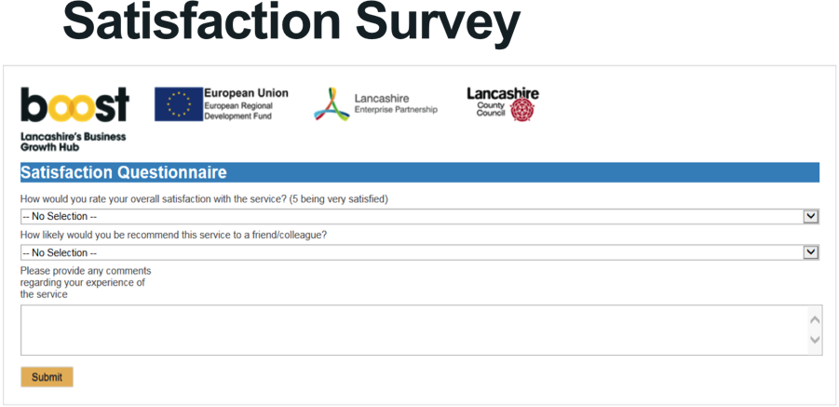

- Data, monitoring, reporting, evaluation and value for money

- How has the LEP ensured that the systems and processes were in place for the Growth Hub to comply with the metrics and evaluation standards as laid out in the 2018-2019 “Monitoring & Evaluation Framework”?
  - Please include information on the processes for accurately collecting both aggregated and non-aggregated (firm-level) data categories.
  - Please detail your experience in collecting unique business identifiers (e.g. Companies House Registration Number, VAT/PAYE and postcode), is the LEP and/or Growth Hub able to do this?
  - Have there been any challenges faced in collecting the requested data? Please provide detail.
We have established a robust CRM system using the Evolutive platform and now collect a comprehensive set of data on each business. Each year we have updated the data we collect based on the latest BEIS Metrics and Evaluation Framework. This includes the baseline position at the initial contact of each business with the Growth Hub, a detailed record of all interventions with each business, the outcome of the interventions and the net impact on the business. The system also records the destination where businesses have been referred onto other business support, including national programmes.
From 2016-17 onwards we have included customer feedback mechanisms in line with BEIS guidance. We also captured qualitative feedback on customer satisfaction as part of the independent evaluation of the Growth Hub during 2017 and 2018 together with an analysis of value for money.
Included in the data fields are Companies Registration Number and postcode as the primary unique business identifiers.
All Growth Hub Delivery organisations are tied in contractually to using the Boost CRM system and all interventions and referrals are recorded on the system. We also collect information on all outcomes and outputs related to each company assisted. The system is fully GDPR compliant to enable businesses to be referred seamlessly from one provider to another.
Performance monitoring
We also use the CRM system to track the impact of Growth Hub on businesses supported. We gather information on jobs created, new businesses launched and the GVA impact of interventions. We can monitor data by local authority area, by industrial sector and destination of referrals.
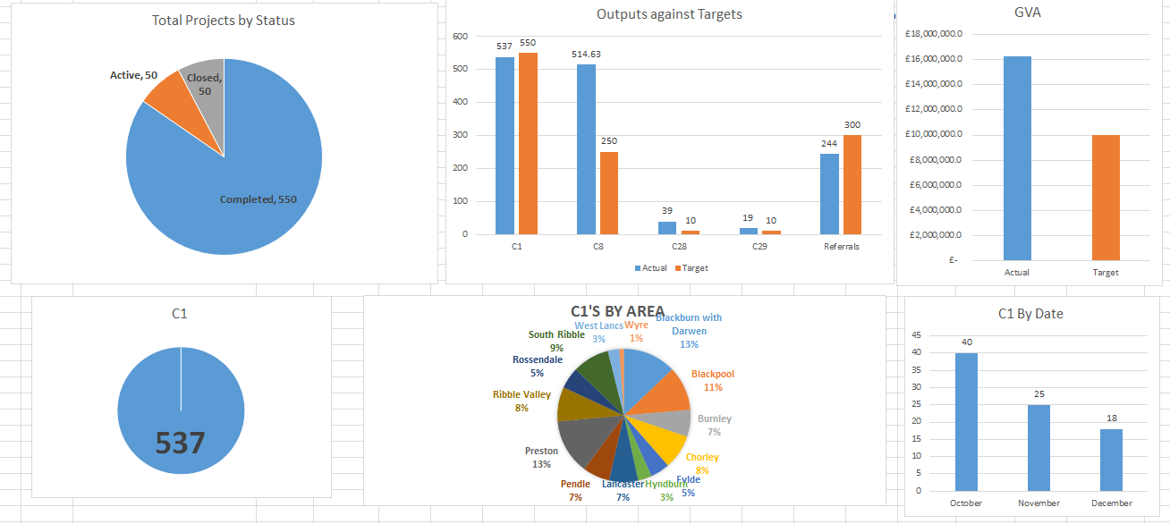
- Are you currently using, or planning to use the ‘firm level data’ collected by the LEP and/or Growth Hub to undertake qualitative and/or quantitative assessments of the Growth Hubs impact on those businesses receiving ‘medium’ and ‘high intensity’ support?
  - If so, what will these assessments examine? E.g. economic impact, operational efficiency, business productivity, customer satisfaction etc.

Yes – the data collected is used to support the independent evaluation of the Growth Hub. The scope of the evaluation was:

Relevance and consistency: exploring the continued relevance and consistency of the Growth Hub in light of contextual changes, such as shifts in policy, economic circumstances and technological advancements.
Progress against agreed targets: setting out project progress when measured against set targets, over/under performance and projected lifetime results;
Experience of delivering and managing the Growth Hub: outlining the practical experience of implementing and managing the project, lessons learned and evidence of best practice which can be applied to the delivery of other projects.
Economic impact attributable to the project: demonstrating the economic impacts attributable to the project, capturing those that were intended, actual and also wider outcomes which have provided added value to the local economy.
Cost effectiveness and value for money: a robust assessment of cost- effectiveness and value for money based on the balance of quantified costs and benefits, in light of intended and unintended impacts.

- How are you measuring the impact your Growth Hub has had in terms of businesses (or individuals) acting on the help/advice they received from the Growth Hub? What have you found?

We collect beneficiary feedback from the business supported by the growth hub on an ongoing basis and use this both to improve the quality of service and to respond to business needs.. The independent evaluation also included feedback from the businesses supported by Boost. Overall most companies reported good/very good on the quality of support received. 69% of businesses reported that they had made some progress in developing products and services, while 56% reported progress in entering new markets. 56% of firms also indicated that they were now more efficient and productive.

We also collect case studies, where companies are willing to share their experience of being supported by the Growth Hub.

https://www.boostbusinesslancashire.co.uk/category/case-studies/

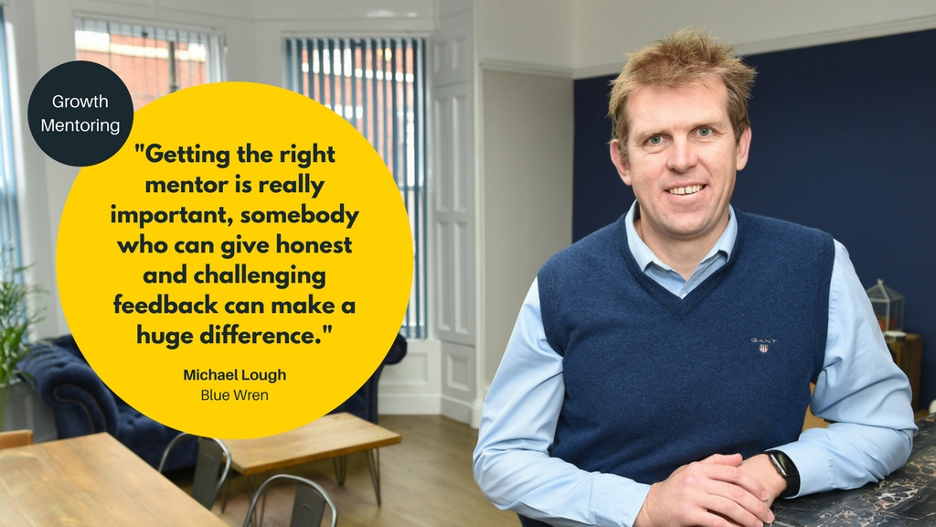

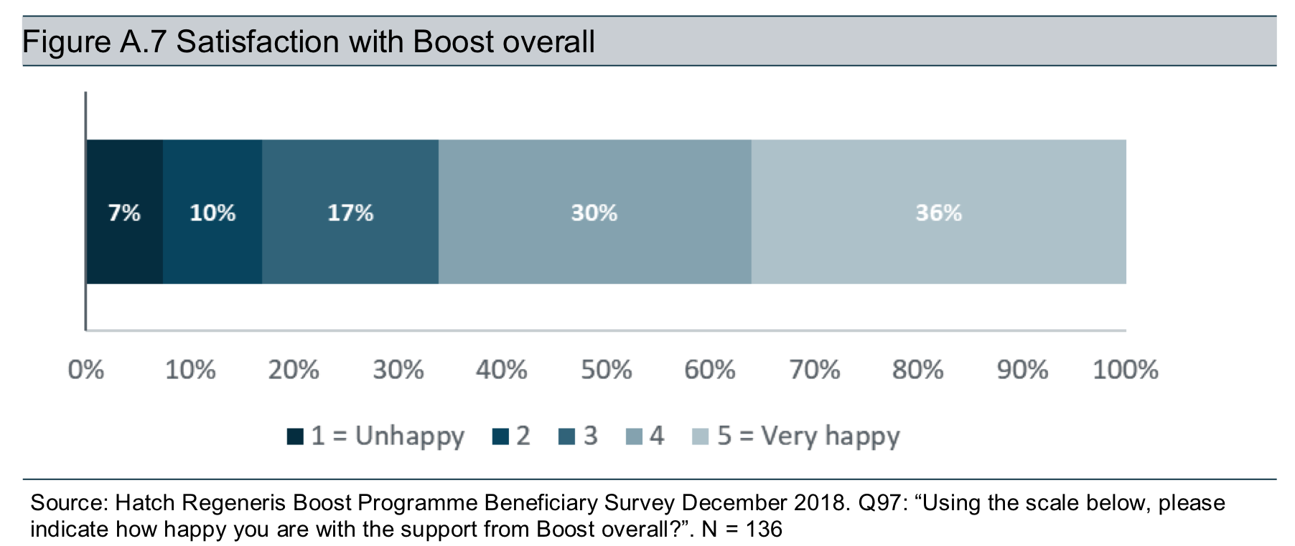

- Scale-Ups

- There is an enhanced focus on identifying and supporting high growth potential/scale up businesses in 2018-19. Please provide an update on the progress of the LEP’s Scale-Up Plan in terms of providing services to scale up businesses through the Growth Hubs as defined in Principle 5 of your Grant Offer Letter. How has this developed and built on local Scale-Up plans? Please provide details of any ‘high-growth or scale-up’ programmes that you are either delivering or promoting via the Growth Hub and what can you tell us about their impact?
Since its inception, Boost has been focused on those businesses that have Growth Potential. The scale up challenge relies on identifying those companies that are able to grow who have the right mentality and culture to want to grow, and have the right teams in place to drive that growth. We have systems in place to monitor the employment and turnover growth of all the businesses supported by the Growth Hub.
The emphasis of the Lancashire Business Growth Hub is on existing businesses that will generate additional GVA and create further job opportunities as part of their overall growth objectives. But BOOST also supports innovative high value start-ups, to establish and then grow.
We also target new and young businesses with high growth potential. We specifically exclude generic (low-medium growth) business, lifestyle businesses and businesses without a capacity for growth.
The Business Support Management Board of the LEP has considered the issue of Scale-Ups at its recent meetings and is currently developing a strategy to support scale ups within Lancashire; this will be integrated into the forthcoming Lancashire Industrial Strategy. In addition to this LEP funding programmes expect delivery organisations to consider scale ups in the development of new initiatives.
From January 2019 the core Growth Hub services have been expanded to include a Scale-up component. The Boost Bespoke service is charged with identifying and working with Lancashire businesses who fit the following definition:
‘Scale-Up businesses, with more than 10 employees at the beginning of the period which show a plausible potential to have an average annual growth in employees or turnover greater than 20per cent per annum over a three year period.’
The Core LCC Growth Hub team also attend the Scale up Institute workshops and forums in order to keep appraised of latest initiative and opportunities.

Lessons Learned/Further Activity
Lessons learned/good practice in 2018-2019.
Please indicate what lessons you have learned to date and how this has helped the LEP improve the Growth Hub service.

- What has worked well?
- What has not worked well?
- How has the LEP learnt from challenges it has faced in delivering its Growth Hub and how has this helped to improve capability and delivery of the Growth Hub?

Worked well:
Growth Hub performed extremely well in terms of its targets to engage with and support growth oriented businesses.

Worked well in terms of sharing business info and coordination of support from core business services. This means that there has been a real clarity on which services are most relevant to each business and removed the potential duplication of services.

Not well in terms of wider public funded business support, particularly universities in terms of 2 way referrals and feedback on the outcome of the support provided. GDPR in May 2018 meant that a number of agencies had to review data sharing protocols and this stalled the efforts to achieve a county wide cooperation agreement.

There has also been limited success in targeting those companies who had not previously accessed support. From January 2019 this is being addressed by introducing an additional ‘New to Boost’ target into delivery contracts.

EU Exit
Please provide details of how the LEP and the Growth Hub are supporting the local business community in the context of EU Exit:

We disseminate BEIS Brexit briefings to local businesses and collect latest feedback and issues from them and report back to BEIS. We have introduced additional content to the Boost website specifically to highlight issues around EU exit and have included links to the latest .gov and HMRC guidance resources:

https://www.boostbusinesslancashire.co.uk/about-boost/brexit/

Case Studies/Best Practice

Please provide up to three case studies that showcase the Growth Hub best. When choosing please ensure the Case Study is no more 12 months old. You may also wish to consider case studies that align to the LEP’s Strategic Economic Plan priority sectors/planned Local Industrial Strategy.

Please see attached three pdf files case studies relating to the following businesses who were supported by the Growth Hub in 2018-19:

- Service Alliance Limited
- Brooks Accountants
- Pie Mezzanae





Note: If you have any additional material that you think would further illustrate the work and impact of your Growth Hub on driving business growth and/or increasing productivity please attach these, listing what you are sending within your covering email. This could include info-graphics, diagrams and flow charts or case studies.

Other information could include quotes from businesses you have assisted and any innovative or collaborative activity with intermediaries.

